Answer the questions below within **100 minutes**. Use **Visual Studio Code** and submit your answer in an “**ipynb**” file.

1. **Solving Linear Equation**

Solve the following system of linear equations with the following requirements,

* + - You must determine whether the equations are **diagonally dominant programmatically**. **If the equation is not diagonal**, then **print an error message**.
    - If the equations are **diagonally dominant**, use **Gauss-Seidel method** and set **max-iterations** with **15**. **Otherwise**, show a message telling the equations are **not diagonally dominant**.
    - Use a **pre-defined threshold $ϵ=0.0xx$** , where xx is the last two digits of your NIM. If the last two digits of your NIM are **00**, so make the threshold **0.010**.

*Example:*

NIM = 24401073**74**, then the $ϵ$ will have a value of $ϵ=0.074$

NIM = 24401073**00**, then the $ϵ$ will have a value of

* + - Use the value 0 as the initial value of x1, x2, and x3.

Then, show the result for each equation and check whether the **equations** below are **convergent** or **not** and **print** the **value** of **x1**, **x2**, and **x3** in **each iteration**.

Below are the systems of linear equations that you need to solve:

$$7x_{1}-2x_{2}-{3x}_{3}=17 \\ 4x_{1}-6x_{2}+{1x}_{3}=8 \\ x_{1}+2 x_{2}-4x_{3}=11$$

$$12x_{1}-4x_{2}+2x_{3}+3x_{4}=7 \\ {3x}_{1}+7x_{2}-x_{3}-3x_{4}=5$$

$${-x}_{1}+{3x}_{2}+9x_{3}+2x_{4}=12$$

$$-5x_{1}+x_{2}-2x_{3}+9x_{4}=8$$

$$2x_{1}-5x_{2}+{3x}_{3}=13 \\ 3x_{1}+6x_{2}+{4x}_{3}=25 \\ {-x}_{1}-3x_{2}+2x_{3}=7$$

$$7x_{1}-3x_{2}-x_{3}=8 \\ 2x_{1}-5x_{2}+x_{3}=5 \\ {-3x}_{1}+2x_{2}-8x_{3}=1$$

$$7x_{1}-x_{2}+5x_{3}+x_{4}=10 \\ -x_{1}+4x_{2}-x_{3}+x_{4}=5$$

$${3x}_{1}-{3x}_{2}+10x_{3}+2x_{4}=7$$

$${-2x}_{1}+3x_{2}-4x_{3}+11x_{4}=14$$

$$x_{1}-3x_{2}+2x_{3}=6 \\ 3x_{1}-2x_{2}+{4x}_{3}=9 \\ {2x}_{1}+x_{2}-2x_{3}=4$$

$$2x_{1}+7x_{2}-{3x}_{3}=11 \\ x_{1}-2x_{2}-{3x}_{3}=1 \\ {-x}_{1}+3x_{2}-2x_{3}=6$$

Snippet code for the equations:

Xs = [

  [

    [7, -2, -3],

    [4, -6, 1],

    [1, 2, -4]

  ],

  [

    [12, -4, 2, 3],

    [3, 7, -1, -3],

    [-1, 3, 9, 2],

    [-5, 1, -2, 9]

  ],

  [

    [2, -5, 3],

    [3, 6, 4],

    [-1, -3, 2]

  ],

  [

    [7, -3, -1],

    [2, -5, 1],

    [-3, 2, -8]

  ],

  [

    [7, -1, 5, 1],

    [-1, 4, -1, 1],

    [3, -3, 10, 2],

    [-2, 3, -4, 11]

  ],

  [

    [1, -3, 2],

    [3, -2, 4],

    [2, 1, -2]

  ],

  [

    [2, 7, -3],

    [1, -2, -3],

    [-1, 3, -2]

  ]

]

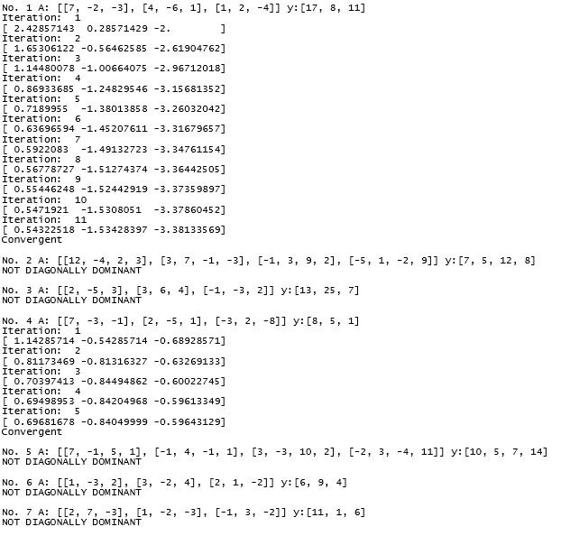

**Figure 1. Gauss Seidel Result with Epsilon 0.01**

1. **Regression and Plotting**

Create a **Least Square Regression** from the **matrix (x, y)** in **“matrix.txt”** file, then show the **plotting** result with the **Least Square Regression** using **matplotlib**. You need to show each **plotting** **point** of **matrix (x,y)** and the **Least Square Regression** in the **graphic** with **different** **colors**.

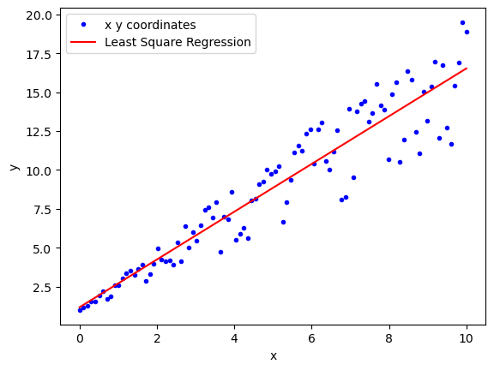

**Figure 2. Least Square Regression Plot Result**

1. **Newton Raphson**

Find the **root** of the equation **f(x)** below by using **Newton Raphson** method:

$$f\left(x\right)=2x^{3}+6$$

To find the **root**, here are the requirements you need to know:

* + **First guess** of the value is **2**.
    - The **tolerate error $0.0xx$** , where **xx** is the last two digits of your NIM. If the last two digits of your NIM are **00**, so make the **tolerate error** **0.010**.

*Example:*

NIM = 24401073**74**, then the $ϵ$ will have a value of $ϵ=0.074$

NIM = 24401073**00**, then the $ϵ$ will have a value of

* + The number of **max iterations** is **20**.
  + **Print** the **result** of the **root** in **each iteration**. If the **iteration** is **over** the **max iterations**, **print** an **error message**.

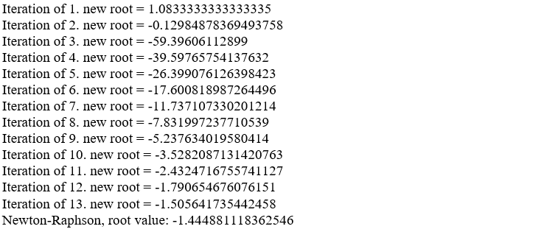

**Figure 3. Newton Raphson Result with Tolerate Error 0.055**

1. **Integral Riemann**

You can freely choose **one of the methods** between **Left Riemann**, **Right Riemann**, **Midpoint Rule**, or **Trapezoid Rule** to find the **approximate** result of $\int_{1}^{3}{{2x}^{3}+ 3x^{2}}dx$ with **3000 evenly spaced grid points** over the whole interval, then **print** the result.